Documentation – heart-disease

Repo: <https://github.com/HuberNicolas/heart-disease>

About the project

Python Version: 3.8.5 (64-bit)

R Version: 4.0.4 (64-bit)

|  |  |
| --- | --- |
| Name of the folder | Description |
| 0 raw .data | Contains the raw data (incl. .md5 hashes) from the [source](https://archive.ics.uci.edu/ml/machine-learning-databases/heart-disease/). |
| 1 raw .csv | Contains the renamed .csv files and the formatter script (incl. .md5 hashes). |
| 2 formatted .csv | Contains the formatted .csv files without a header (incl. .md5 hashes). |
| data | Contains the datasets (incl. header) the analysis was run (incl. .md5 hashes). |
| logs | Contains the logfiles of the scripts. |
| plots | Contains the plots that were generated during the analysis. |
| rand_forest_feature_selection(25) | Contains the datasets (incl. header) after the random forest selection. These sets contain 25 features, that can “explain” 80% of the data. |

About the datasets

The following explanations are based on the heart-disease.NAMES file.

**# of Instances:**

* Cleveland: 303
* Hungarian: 294
* Switzerland: 123
* Long Beach VA: 200

**Number of Attributes:** 76 (including the predicted attribute) See appendix for the complete list. (Missing Attribute Values: Several. Distinguished with value -9.0.)

“This database contains 76 attributes, but all published experiments refer to using a subset of 14 of them. In particular, the Cleveland database is the only one that has been used by ML researchers to this date.”

**Class distribution:** (Classtype (domain [0,4]) is referring to feature 58 “num”, diagnosis of heart disease (angiographic disease status). This indicates, how severe the disease is (0: no disease, 4: most severe disease)

|  |  |  |  |  |  |  |
| --- | --- | --- | --- | --- | --- | --- |
| Database | Class = 0 | Class = 1 | Class = 2 | Class = 3 | Class = 4 | Total |
| Cleveland | 164 | 55 | 36 | 35 | 13 | 303 |
| Hungarian | 188 | 37 | 26 | 28 | 15 | 294 |
| Switzerland | 8 | 48 | 32 | 30 | 5 | 123 |
| Long Beach VA: | 51 | 56 | 41 | 42 | 10 | 200 |

Description of the process-pipeline

**General:**

Note: For this data science project, **only the following. data files were used**:

|  |  |
| --- | --- |
| Filename | Md5-Hash |
| cleveland.data | 2388e97e27676171aa0a1c61bb4a3670 |
| hungarian.data | ce4a62b8de90d93d616ede3253239851 |
| long-beach-va.data | 381cee4b51b786623402929e2cc1ccf9 |
| switzerland.data | b2a3e9cc9c82dc0f8fa19bb851db495d |

These .data files were **not** used:

|  |  |
| --- | --- |
| Filename | Md5-Hash |
| new.data | 046bd9f619c20148b261b3e392c02591 |
| processed.cleveland.data | 2d91a8ff69cfd9616aa47b59d6f843db |
| processed.hungarian.data | 22e96bee155b5973568101c93b3705f6 |
| processed.switzerland.data | 9a87f7577310b3917730d06ba9349e20 |
| processed.va.data | 4249d03ca7711e84f4444768c9426170 |
| reprocessed.hungarian | 3698a53d41cccc2e4499e1273c055378 |

For the sake of completeness, nonetheless, we did include the whole folder.

Preparing the datasets:

First step: rename .data files (0 raw .data) to .csv (1 raw .csv).

Second step: format the .csv files via python script “formatter” (2 formatted .csv). This step was needed because the original data was badly formatted. The formatter.py formats the datasets, such that all features of one patient are one row and not scattered over multiple rows.

Third step: adding a header for the 76 features (data).

We finally get 4 files in our data folder:

|  |  |
| --- | --- |
| Filename | Md5-Hash |
| cleveland_76_header.csv | a67792681f83998d97e332bfb41efee0 |
| hungarian_76_header.csv | 6c86829818559cfb434126c61d5cb25c |
| long-beach-va_76_header.csv | 4dde4782acbbdac7b2198bb676fea13f |
| switzerland_76_header.csv | d4a1d37007107ee2fb73be8a4122bf32 |

Important note: At this moment, no entries were modified.

**Process of Visualization and Analyse**

The processing of the data was done in the following order. Pre-processing and (general) visualization, feature selection, reduction, and finally classification. We focus and start in this project on working with the whole dataset and not the already pre-processed files, which only include a tiny subset of the features, to finally compare the locations with each other.

It is in general a good idea to start with some visualizations get a rough overview and kind of an intuition of the (abstract) data. In a second step doing a feature, the selection is crucial, because 76 features go beyond the constraints of reasonable analysis. Using the RandomForestClassifier found 25 features that have the most impact on the data. The two other approaches were t-SNE and UMAP and in addition to this using autoencoders with R. Several different classification algorithms, namely

* Logistic Regression
* Naïve Bayes
* SVM (linear, poly (degree = 3) and kernel (rbf))
* KNN (nn = 5)
* Neural Networks
* Autoencoders (in R)

were processed before finally a conclusion was drawn from the results and plots.

Disclaimer:

* The Swiss dataset was highly unbalanced (very few 0’s and 4’s in the “num” section which is they-feature). That causes the ROC-score to struggle.
* In addition to this, the Swiss dataset has no information about the chol level (default 0). That means it was not possible to plot the second scatter plot.
* Overall, the Swiss data set was not very suitable for this kind of analysis. The above-mentioned difficulties were (amongst other things) for the low model accuracy.

In the following, there is a summary of all the different plots, how they were generated, and which technique/method/model was used.

1. **PREPROCESSING & DATA VISUALIZATION**
2. Visualize Max heart rate vs age with the target variable “num” (1-4) : Scatter Plot
3. Visualize cholesterol level vs age with the target variable “num” (1-4) : Scatter Plot
4. Visualize blood pressure vs chest pain : Box Plot
5. Visualize correlation between features and target variable “num” (1-4) : Bar Plot (.corrwith)
6. Visualize correlation between features and target variable “num” (1-4) : Heatmap (.corr)
7. Visualize blood pressure vs age with the target variable : LMplot (.lmplot : scatterplot with an optional overlaid regression line)
8. Visualize heart rate vs age with the target variable : LMplot (.lmplot : scatterplot with an optional overlaid regression line)
9. Visualize distribution of age according to the presence of heart disease : KDEplot (.kdeplot : represents the data using a continuous probability density curve)
10. Visualize comparison between the distribution of the disease according to age and sex : Bar Plot (.groupby)
11. **FEATURE SELECTION**
12. Visualize feature importance : Bar Plot (RandomForestClassifier) => saved under / rand_forest_feature_selection(25)
13. **REDUCTION & VISUALISATION**
14. Visualize feature reduction for different perplexities : Scatter Plot (TSNE)
15. Visualize feature reduction : Scatter Plot (UMAP)
16. **CLASSIFICATION**
17. Visualize logistic regression : Heatmap (LogisticRegression)
18. Visualize performance of logistic regression : ROC plot + AUC result ; Print accuracy : (metrices.accuracy_score)
19. Visualize naïve Bayes : Heatmap (GaussianNB)
20. Visualize performance of naïve Bayes : ROC plot + AUC result ; Print accuracy : (metrices.roc_auc_score)
21. Visualize performance of SVM (linear kernel) : ROC plot + AUC result ; Print accuracy : (metrices.accuracy_score)
22. Visualize performance of SVM (poly (d=3) kernel) : ROC plot + AUC result ; Print accuracy : (metrices.accuracy_score)
23. Visualize performance of SVM (rbf kernel) : ROC plot + AUC result ; Print accuracy : (metrices.accuracy_score)
24. Visualize SVM (linear, poly (d=3) and rbf kernel) : Heatmap (svm.SVC(kernel = TYPE))
25. Visualize KNN : KNeighborsClassifier(n_neighbors = 5, algo = “ball_tree”) ; Print accuracy : (accuracy_score)
26. Visualize performance of KNN : ROC + plot ; Print cross validation : (cross_val_score)
27. Visualize performance of simple neural Network : model = Sequential(), model.fit()
28. **ACCURACIES**

Above is a summary of the scripts (and their log-files) of the accuracy in the form of a table. X is dependent on the associated method (first column) for instance using logistic regression, X_pred is named LR_pred).

1. **AUTOENCODERS**

**Cleveland analysis**

* Feature selection (first five most important)

Laddist – “distal left anterior descending artery” seems to be one of the most important features. Indeed, it is part of the left main coronary artery (LAD), considered the most important because it supplies more than half of the blood to the heart.

Thal – “exercise thallium scintigaphy” is a diagnostic method of nuclear medicine that enables visualization of well-perfused and vital tissue of myocardium by means of 201thallium absorbed by its cells. This method is used to evaluate the character of soft tissue lesions. The feature is divided into three categories from normal to defect.

Om1 – “first obtuse marginal branch” is also an important vessel that is part of the left main coronary artery (LAD).

Ca – “number of major vessels”.

Rcaprox – “proximal right coronary artery” is part of the right coronary artery (RCA) in contrast to LAD.

* Autoencoders

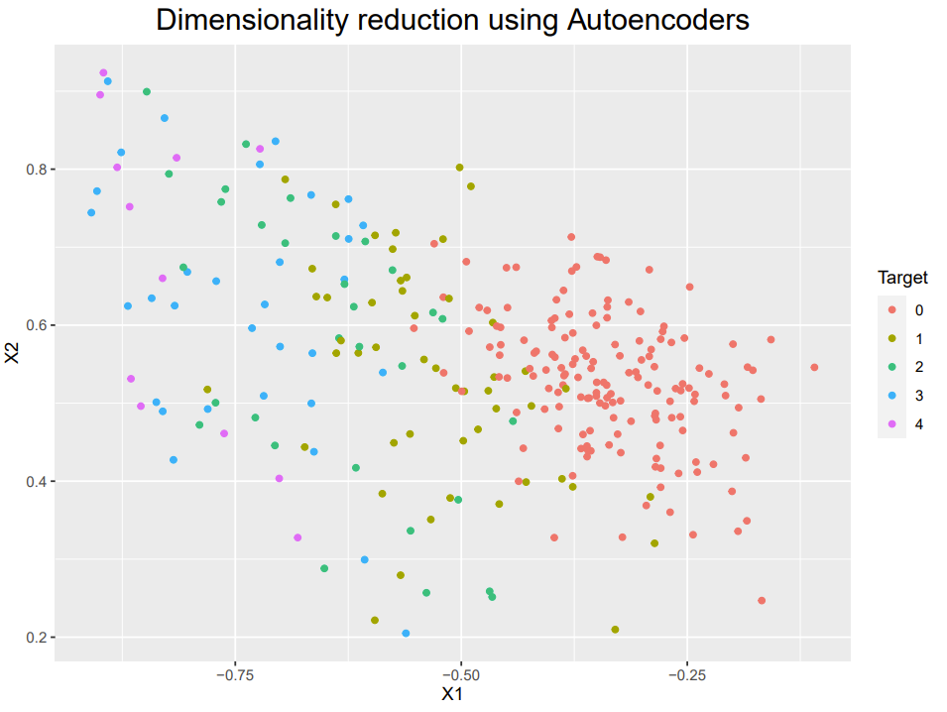

**Hungary analysis**

* Feature selection (first five most important)

Cp – “chest pain” seems to be selected as the most important feature. It is divided into four categories: type: 1 = typical angina; 2 = atypical angina; 3 = non-angina pain; 4 = asymptomatic.

Painexer – “pain provoked by exertion”. It is divided into two categories: 1 if the patient felt pain during effort, 0 otherwise.

Oldpeak – “exercise-induced ST depression relative to rest” is an exercise electrocardiography test to evaluate whether the trace in the ST segment is abnormally low below the baseline which is often a sign of myocardial ischemia.

Lvx4 – not used / not described / no information regarding this feature.

Exang – “Exercise-induced angina”. It is divided into two categories: 1 if yes, 0 otherwise.

* Autoencoders

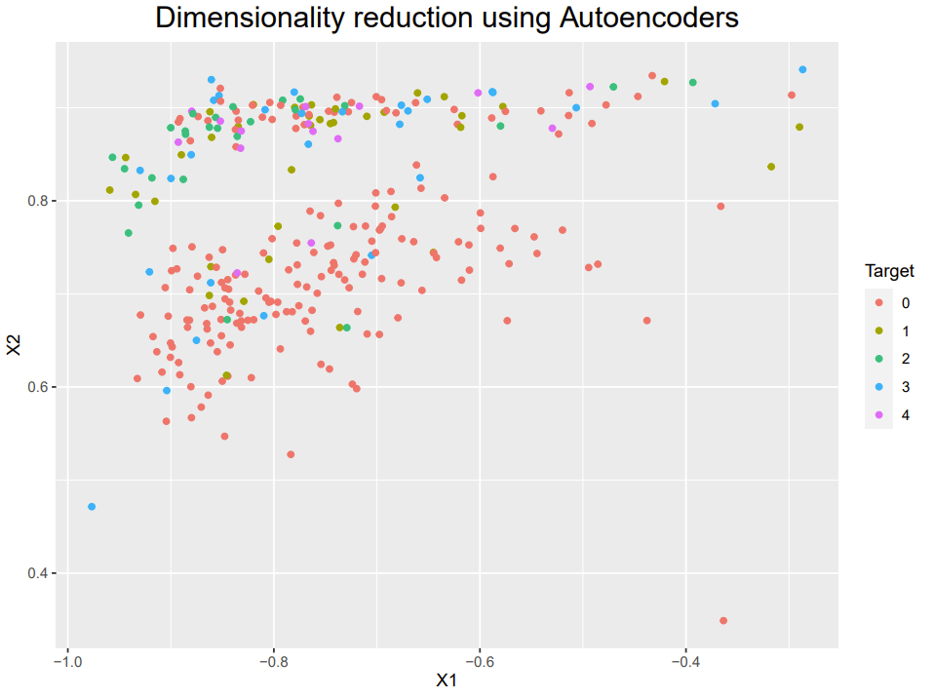

**Switzerland analysis**

* Feature selection (first five most important)

Cxmain – “circumflex”. It is another vessel that is part of the left main coronary artery (LAD), considered the most important because it supplies more than half of the blood to the heart.

ID – not relevant.

Thalach – “maximum heart rate achieved” refers to the maximum heart rate achieved during thalium stress test. At first sight, we might suppose that the maximum heart rate is lower for those diagnosed with heart diseases. Indeed, it seems logical to assume that a higher rate indicates a satisfactory heart condition since it managed to increase its rate to such a level during the stress test.

Tpeakbps – “peak exercise systolic blood pressure”.

Age – “age of the patients”.

* Autoencoders

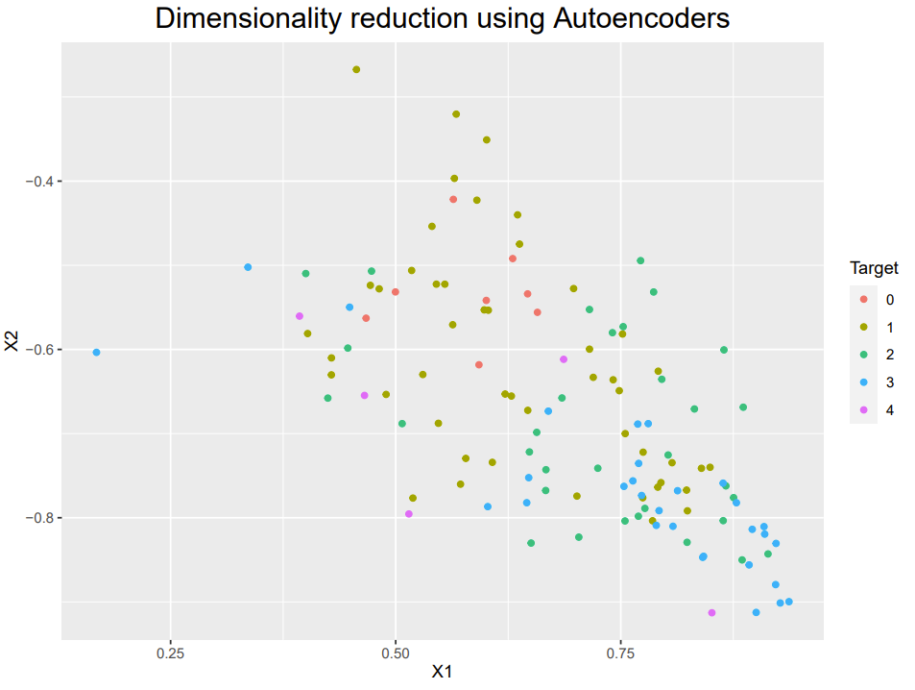

Long Beach analysis

* Feature selection (first five most important)

Rcaprox – “proximal right coronary artery” is part of the right coronary artery (RCA) in contrast to LAD.

Ladprox – “proximal left anterior descending artery” which is part of LAD.

Cxmain – “circumflex”. It is another vessel that is part of the left main coronary artery (LAD), considered the most important because it supplies more than half of the blood to the heart.

ID – not relevant.

Cday – “day of cardiac catheterization”. Not relevant.

* Autoencoders

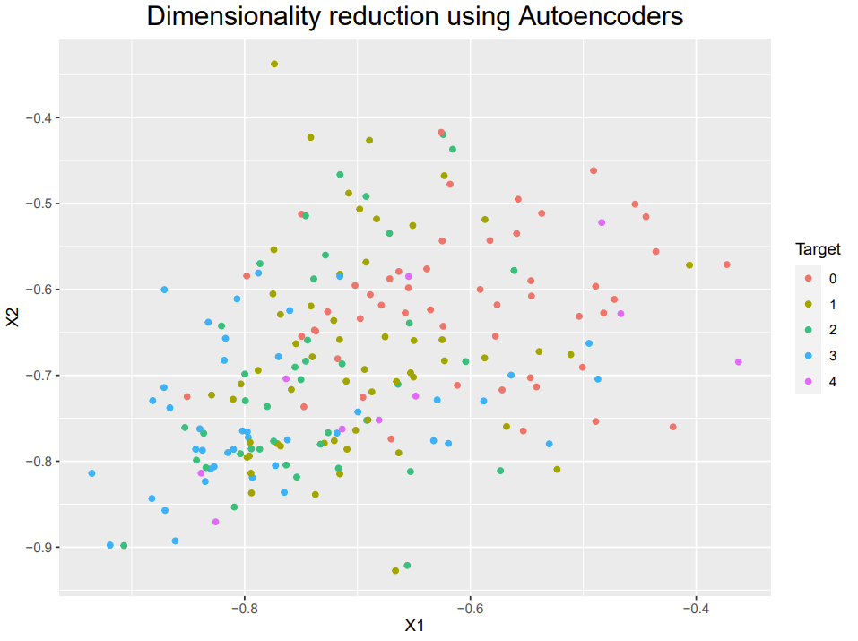

**Conclusion:**

The following 3 questions were formulated in our proposal:

“Are some parameters more likely to be associated with heart disease?”

“Can we predict heart disease while using statistical methods?”

“Can we find any differences between the different regions in terms of predicted risk factors?”

We will discuss our findings during the presentation and summarize the most important here:

With the random forest method, 25 features were selected that explain about 80% of the data. Since the list of features is relatively long, this trade-off has been made. It is notable that also obviously some features were selected, that have no impact on the risk of CVD (for instance ID in Switzerland and Vancouver). For the algorithm, the ID parameter seems to have an important impact on the outcome, whereas in the real world this is not the case and shows, how the “algorithm” thinks”. Other parameters like the chest pain indicator for the Hungarian set were also selected (which makes also in medical perspective more sense). Naming a set of parameters for all locations seems not realistic, one reason that we came up with is, that the sheer list of features is just too much: Even the top (five) of the 25 selected features does only explain the outcome in a degree of the low percentage.

Regarding the prediction of heart disease, this project is sobering. For some datasets, the prediction was not good and there is a variation in the accuracy regarding the different methods of prediction. This is shown in the performance measurement table

There are only minor differences between the locations, this can be seen in various plots, for instance, distribution of age and the type of disease. One reason could be because the 4 locations have a similar socio-demographic structure.

**Limitation and Outlook:**

In retrospect, were now able to reflect on the project and to discuss improvements that could be made on further projects. We start with the limitation:

* The dataset was a bit outdated. The conditions have been changed and.
* The dataset of Switzerland is very unbalanced, which makes it hard to draw a reliable conclusion. This directly affects several models, such that it was not possible to generate them, even with shuffling the samples.
* The features were not described. We do not know, how these features were measured and if there are differences between the locations. Also, in some datasets are important features not existing, for instance, cholesterol in the Swiss dataset.
* Furthermore, it seems like some features are senseless, for instance, the day of cardiac catherization.
* It is not clear if the num=0 class is a control group or not.

Having said that, we also record some thoughts for further improvements:

* We can tune the model parameters for each dataset to achieve higher accuracy. That means the pipeline may look different and it may not be possible anymore to compare different regions, but (hopefully) the accuracy will increase.
* Expanding the choice of the features to maybe 50 would be interesting. Also, maybe a reduction could gain more insights.
* Working with a current dataset and then compare the results. What did change, what stayed the same.

**Appendix:**

Complete attribute documentation:

1. id: patient identification number
2. ccf: social security number (I replaced this with a dummy value of 0)
3. age: age in years
4. sex: sex (1 = male; 0 = female)
5. painloc: chest pain location (1 = substernal; 0 = otherwise)
6. painexer (1 = provoked by exertion; 0 = otherwise)
7. relrest (1 = relieved after rest; 0 = otherwise)
8. pncaden (sum of 5, 6, and 7)
9. cp: chest pain type
   * Value 1: typical angina
   * Value 2: atypical angina
   * Value 3: non-anginal pain
   * Value 4: asymptomatic
10. trestbps: resting blood pressure (in mm Hg on admission to the hospital)
11. htn
12. chol: serum cholestoral in mg/dl
13. smoke: I believe this is 1 = yes; 0 = no (is or is not a smoker)
14. cigs (cigarettes per day)
15. years (number of years as a smoker)
16. fbs: (fasting blood sugar > 120 mg/dl) (1 = true; 0 = false)
17. dm (1 = history of diabetes; 0 = no such history)
18. famhist: family history of coronary artery disease (1 = yes; 0 = no)
19. restecg: resting electrocardiographic results
    * Value 0: normal
    * Value 1: having ST-T wave abnormality (T wave inversions and/or ST elevation or depression of > 0.05 mV)
    * Value 2: showing probable or definite left ventricular hypertrophy by Estes' criteria
20. ekgmo (month of exercise ECG reading)
21. ekgday(day of exercise ECG reading)
22. ekgyr (year of exercise ECG reading)
23. dig (digitalis used furing exercise ECG: 1 = yes; 0 = no)
24. prop (Beta blocker used during exercise ECG: 1 = yes; 0 = no)
25. nitr (nitrates used during exercise ECG: 1 = yes; 0 = no)
26. pro (calcium channel blocker used during exercise ECG: 1 = yes; 0 = no)
27. diuretic (diuretic used used during exercise ECG: 1 = yes; 0 = no)
28. proto: exercise protocol
    * 1 = Bruce
    * 2 = Kottus
    * 3 = McHenry
    * 4 = fast Balke
    * 5 = Balke
    * 6 = Noughton
    * 7 = bike 150 kpa min/min (Not sure if "kpa min/min" is what was written!)
    * 8 = bike 125 kpa min/min
    * 9 = bike 100 kpa min/min
    * 10 = bike 75 kpa min/min
    * 11 = bike 50 kpa min/min
    * 12 = arm ergometer
29. thaldur: duration of exercise test in minutes
30. thaltime: time when ST measure depression was noted
31. met: mets achieved
32. thalach: maximum heart rate achieved
33. thalrest: resting heart rate
34. tpeakbps: peak exercise blood pressure (first of 2 parts)
35. tpeakbpd: peak exercise blood pressure (second of 2 parts)
36. dummy
37. trestbpd: resting blood pressure
38. exang: exercise induced angina (1 = yes; 0 = no)
39. xhypo: (1 = yes; 0 = no)
40. oldpeak = ST depression induced by exercise relative to rest
41. slope: the slope of the peak exercise ST segment
    * Value 1: upsloping
    * Value 2: flat
    * Value 3: downsloping
42. rldv5: height at rest
43. rldv5e: height at peak exercise
44. ca: number of major vessels (0-3) colored by flourosopy
45. restckm: irrelevant
46. exerckm: irrelevant
47. restef: rest raidonuclid (sp?) ejection fraction
48. restwm: rest wall (sp?) motion abnormality
    * 0 = none
    * 1 = mild or moderate
    * 2 = moderate or severe
    * 3 = akinesis or dyskmem (sp?)
49. exeref: exercise radinalid (sp?) ejection fraction
50. exerwm: exercise wall (sp?) motion
51. thal: 3 = normal; 6 = fixed defect; 7 = reversable defect
52. thalsev: not used
53. thalpul: not used
54. earlobe: not used
55. cmo: month of cardiac cath (sp?) (perhaps "call")
56. cday: day of cardiac cath (sp?)
57. cyr: year of cardiac cath (sp?)
58. num: diagnosis of heart disease (angiographic disease status)
    * Value 0: < 50% diameter narrowing
    * Value 1: > 50% diameter narrowing

(in any major vessel: attributes 59 through 68 are vessels)

1. lmt
2. ladprox
3. laddist
4. diag
5. cxmain
6. ramus
7. om1
8. om2
9. rcaprox
10. rcadist
11. lvx1: not used
12. lvx2: not used
13. lvx3: not used
14. lvx4: not used
15. lvf: not used
16. cathef: not used
17. junk: not used
18. name: last name of patient (I replaced this with the dummy string "name")